Module | Anticoagulation management: patient’s guide to self-monitoring
Topic | How oral anticoagulants (warfarin) affect blood clotting
Audience | Self-monitoring warfarin patient
Type | Core content
Version | 4

1. Introduction

The aim of this topic is to give you background information on how one group of anticoagulant agents - vitamin K antagonists - affect blood clotting.

By the end of this topic you should be able to:

- List the components of blood
- Describe how blood clots
- Understand how vitamin K antagonists affect blood clotting

2. Check your understanding

Before you start reading this topic check how much you already know by taking a short quiz. You will have an opportunity to take the quiz again at the end of the module, where we will reveal the correct answers.

a) What are the main components of blood? : (Please tick the response that you think best answers this question)

i) Red cells, white cells, grey matter, plasma

ii) Red cells, white cells, platelets, plasma

iii) Red cells, white cells, platelets, histamine

b) Platelets help my blood to clot

True / False

c) There now follows a set of statements about how blood clots. Please can you indicate if these statements are true or false

i) When blood clots it changed from a liquid to a solid state.

True / False

ii) When you bleed, platelets in blood become 'sticky' and clump together to ‘plug’ the site of the injury.

True / False

iii) The release of proteins called clotting factors result in the formation of fibrin, which strengthens the blood clot

True / False

d) Warfarin prevents my blood from clotting by doing the following : (Please tick the response that you think best answers this question)

i) It prevents platelets from sticking together

ii) It prevents clotting factors from forming

iii) It repairs the damaged blood vessel

3. What is blood?

Blood is the liquid that gives you life. It is pumped by the heart and flows through blood vessels – arteries, capillaries and veins – to spread it to the rest of your body.

Blood is made up of watery yellow-coloured liquid called plasma, in which three types of cells float. Cells are the building blocks that make up your body. There are three types of blood cells – red cells, white cells and platelets. Each part of blood has its own role:

(Image - test_tube.svg)

Plasma – carries water, nutrients, salts and drugs to your cells, and carries waste away from those cells.

Red cells – are full of haemoglobin, a protein which contains iron. Haemoglobin picks up oxygen from your lungs, and then carries it to body tissues and cells.

White cells – defend your body against infection

Platelets – help your blood to clot.

4. How does blood clot?

Blood clotting or "blood coagulation" is when (liquid) blood is changed into a solid state to form a blood clot. When you bleed, the platelets in blood become 'sticky' and clump together to ‘plug’ the site of the injury. At the same time, damage to your body tissue releases proteins called clotting factors, which respond in a complex cascade – the ‘coagulation cascade’ - to form fibrin strands to strengthen this platelet plug.

ACTIVITY (desirable content)
Now take a look at the following animation, which illustrates this blood clotting process.

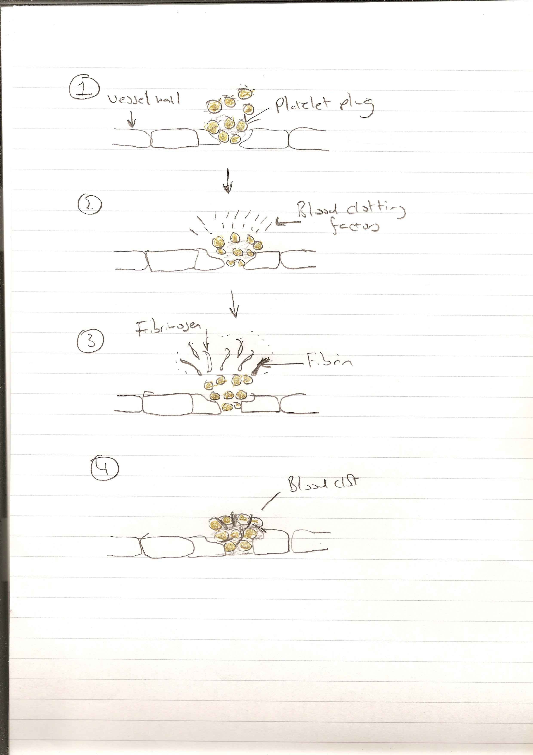
(Can this be represented as an animation? PS … pls miss out fibrinogen label as this is not mentioned in text. Alternatively, there is a good – and simple – You Tube video at http://www.youtube.com/watch?v=--bZUeb83uU.)

5. Why would you need to stop blood from clotting?

Blood coagulation is essential to stop the loss of blood from damaged blood vessels. However, in some conditions potentially harmful clots may form in a healthy blood vessel. This is known as thrombosis. Examples of thrombosis are as follows:

- Blood clotting in an artery to cause a stroke
- Blood clotting in the vein of the leg, causing a deep vein thrombosis (DVT).
- Blood clotting in the main artery going to the lung, causing a pulmonary embolism (PE)

Anticoagulant drugs, including warfarin, prevent thrombosis.

6. How do vitamin K antagonists (including warfarin) act to prevent blood from clotting?

Vitamin K plays an essential role in making the clotting factors described above. As their name suggests, Vitamin K antagonists (VKAs) block vitamin K, preventing these clotting factors from forming. This then decreases your body’s ability to form blood clots, stopping harmful clots from forming and preventing clots from getting bigger.

Currently, warfarin is the most commonly used vitamin K antagonist in the UK. Other VKAs are acenocoumarol and phenindione.

If you would like to learn a little more about how warfarin– and other drugs – affect blood clotting please click here. [link to extra content]

DEMONSTRATE YOUR UNDERSTANDING
Finally, please try to answer the questions at the start of this topic again. Were you able to answer more questions correctly?

