1. What should I learn from this topic?

The aim of this topic is to give you an understanding of the principles of adjusting warfarin doses and INR testing intervals in response to a patient’s INR and history, and to gain a familiarity with the decision support tools that can assist you in managing those on warfarin therapy

By the end of this topic you should be able to:

- Describe the different warfarin initiation regimens
- Summarise the patient information you need to obtain before adjusting the dose of warfarin
- Demonstrate competency in adjusting doses of warfarin in response to a given INR
- Demonstrate competency in adjusting INR testing intervals
- Summarise the advantages and limitations of computerised decision support systems for anticoagulation management
- Demonstrate competence in using HeliconHeart to create a treatment plan
- Demonstrate competence in using a paper-based tool to manage oral anticoagulation

2. Check your understanding

Before you start reading this topic check how much you already know by taking a short quiz. You will have an opportunity to take the quiz again at the end of the module, where we will reveal the correct answers.

- Loading doses of warfarin are required on initiation of warfarin because of the long half-life of warfarin T/F

- Centres typically use loading doses of warfarin 10mg for 3 days when initiating warfarin in newly diagnosed VTE patients T/F

- In patients with newly diagnosed VTE, it is appropriate that the patient receives additional heparin as cover whilst the warfarin loading doses are given T/F

- When initiating anticoagulation, heparin can be stopped once a therapeutic INR has been reached T/F

- There is an increased risk of warfarin-induced skin necrosis on initiation of warfarin in those with Protein C or Protein S deficiency. T/F

- When considering initiation of warfarin, the following factors need to be taken into account: patients age, liver function, concomitant disease states such as heart dysfunction and other medications T/F

- Initiation of warfarin is a relatively safe time for warfarin management and you can take a relaxed approach to this whole phase T/F

- There is little point in determining what is the cause of an abnormal INR in someone who is being monitored long term – the changed dose would be the same whatever the cause T/F

- Fluctuations in INR in an otherwise well patient, may be addressed by looking at temporary causes such as lifestyle changes including alcohol and diet T/F

- An adjustment of 50% of the maintenance dose is the maximum adjustment in a patient, whose INR is consistently out-of-range T/F

- In stable patients with atrial fibrillation, the maximum interval between appointments is 16 weeks. T/F

- There is good evidence to demonstrate that time spent in the therapeutic INR range (TTR) results in less emboli and strokes T/F

- The interval before the next INR test should always be 4 weeks. T/F

- The interval before the next INR test is determined mainly by the change
in INR level in the current test and the preceding one T/F

- Patients with AF who have an INR >5 who are not bleeding should have 1 to 2 doses of warfarin withheld T/F
- The follow up interval should always remain the same in someone taking low dose warfarin whatever the INR result T/F

17. A follow up interval of more than 4 months is safe and cost effective T/F

18. An advisory system using a built in algorithm is much better than a clinician at getting the next dose correct and you should always accept the dose recommendation given Y/N

20. Computerised decision support systems (CDSS) should always supply patient specific advice. True / False

21. There is no evidence that electronic maintenance dosing algorithms result in better control of the INRs and better outcomes for the patient. True / False

3. Initiating warfarin therapy - an introduction

Initiation of warfarin therapy is challenging. As we learnt in Topic 5 (The Pharmacokinetics of Warfarin - link), the response is delayed and difficult to predict, taking up to 8 days to reach constant a plasma concentration of warfarin (steady state). Therefore, when initiating warfarin therapy, loading doses are used to bring the steady state forward.

Care is needed when initiating warfarin. These early weeks of treatment are associated with a high risk of both under-anticoagulation and over- anticoagulation. This often results in clinical complications.

3.1 What are the risks of high loading doses of warfarin?

Care is needed with the initial loading doses of warfarin. When considering initiation of warfarin, the following factors need to be taken into account:

- Patient’s age
- Liver function
- Renal function
- Interacting drugs
- Concomitant disease states (e.g. heart dysfunction)

High loading doses of warfarin may increase the patient's risk of bleeding complications early in therapy by eliminating the production of functional factor VII.

A paradoxical hypercoagulable state can occur due to a severe depletion of Protein C and Protein S. Those who have protein C or protein S deficiency are particularly vulnerable to this. In particular, Protein C has a half-life of only about 8 hours and is therefore depleted quickly after initiation of warfarin therapy. Large loading doses can cause rapid reductions in Protein C which can result in a pro-coagulant state. This has been reported to result in clot extension.

Please read this article about the paradoxical increased risk of thrombosis after initiation of oral anticoagulation due to sudden reduction in protein C and S (this paper is free to access, but you will need to register with the website when prompted to do so)

Rehman, H. Thromboembolic disease: paradoxical increased risk of thrombosis after initiation of oral anticoagulation Thrombus 2005, Volume 9, Number 1.(7-9)
http://www.thrombus.co.uk/_year_search_review.aspx?JID=8&Year=2005&Edition=274

Additionally, those with Protein C and Protein S deficiency are at risk of warfarin-induced skin necrosis if anticoagulation is excessive in the initial stages. This skin reaction occurs over areas of adipose tissue (breasts, buttocks, thighs) and is discussed further in Topic 7 (Adverse Effects of Warfarin - link).

3.2 What is the best way to initiate someone on warfarin?

Due to the risks associated with high loading doses, they are generally not recommended. Instead, if the event being treated is new – for instance an acute pulmonary embolus or an acute proximal DVT, or new-onset atrial fibrillation -
lower loading doses together with heparin for at least 4 days as a bridging therapy are preferred. Heparin should not be discontinued until the INR is within therapeutic range for at least 2 consecutive days.

Traditionally, the Fennerty algorithm (http://www.bmj.com/content/288/6426/1268.full.pdf+html) has been used initiate warfarin, using 10mg, 10mg, 5mg loading doses on the first three days of treatment. However, many centres now use lower doses of 5mg, 5mg, 5mg, or 8mg, 8mg, 8mg on the first three days of warfarin treatment. Those still advocating the use of 10mg, 10mg, 5mg recommend the use of daily INRs to predict patient response. In the event that the INR is significantly raised (because patient is sensitive), then a lower dose is recommended.

Now please take a look at the section on warfarin initiation in the British Committee for Standards in Haematology’s (BCSH) Guidelines on oral anticoagulation with warfarin (4th Edition).
http://onlinelibrary.wiley.com/doi/10.1111/j.1365-2141.2011.08753.x/full

4. Maintaining warfarin therapy – an introduction

One of the aims of the anticoagulant clinic consultation is to advise the patient on their dose of oral anticoagulant (vitamin K antagonist) and on when they should next have an INR test. The most commonly used agent in the UK is warfarin. It is important that the patient is maintained around their target INR as much as possible as evidence has demonstrated that INR control is related to clinical outcomes such as stroke.

This section summarises the steps that should be taken in the anticoagulation consultation to allow you to provide safe dosing and INR testing interval advice.

4.1 Establishing the reason for fluctuations in INR

Unexpected fluctuations of the INR in an otherwise stable patient should be
investigated. Often, it is possible to identify one or more causes; these may include:

• Non-compliance - including missed doses or deviations from the instructed regimen
• Initiation of an interacting drug
• Change in diet or alcohol intake
• Acute worsening in health
• Increased emotional stress (e.g. moving house, bereavement, family troubles)

Therefore, before adjusting the dose of warfarin you should review:

♦ Previous doses of Warfarin
♦ Earlier INR results
♦ Changes in patient’s clinical condition
♦ Changes in medication
♦ Changes in lifestyle
♦ Alcohol consumption

You should also establish if the reason for the fluctuation in INR is a temporary or permanent one. Examples of temporary reasons for INR fluctuation include missed doses or the introduction of a short-term medicine such as an antibiotic. If an INR is out of range because of a temporary reason, usually a temporary dose does adjustment is sufficient; for example, giving a loading dose or asking the patient to omit or take a lower dose for a few days. For long-term or permanent changes including long-term health changes, e.g. heart failure or permanent medication changes such as introduction of simvastatin in hypercholesterolaemia, a permanent dose adjustment may be required.

4.2 Using loading doses of warfarin

In the event that the INR is sub-therapeutic, it is usual to give loading doses of up to 50% of the maintenance dose (and in practice this can vary from 30% to 50%.) The % increase depends on the degree of deviation from the INR target, how long the patient has been out of range and, most importantly, the condition being managed. For example, if warfarin is being used for stroke prevention, then the loading dose need not be as great as compared to when warfarin is used to treat a recent venous thromboembolism.

A loading dose should be rounded up or down to the nearest whole mg. Where the maintenance dose is small, rounding to the nearest whole mg may result in larger than 50% loading doses. Do not offer loading doses as fractions of a mg, i.e. 4.5mg. Either round down to 4mg or round up to 5mg.

The full effect of a loading dose will be seen in a rise in the INR after around 48 hours, so it is advisable not to check the INR again until after 3 days have passed.

4.3 Omitting doses of warfarin

If a patient presents with a high INR, you may have to advise them to omit one or more doses of warfarin. There is usually no need for a dose omission if the patient’s INR is only slightly above their therapeutic range, for example within 0.4 units. For INR values above this, a dose omission for a day or two may be indicated. Please refer to the dosing algorithm or follow the advice on your computerised decision support system (CDSS).

This advice may need to be modified if the patient is bleeding

4.4 Adjusting the maintenance dose of warfarin

If the reason why the INR is deviated is due to a permanent reason such as the introduction of a long-term drug, then a decision should be made to increase/decrease the maintenance dose. When you need to adjust a dose, little is good! Many find it helpful to look at the total weekly dose and, as a general rule, adjust this by 5 – 10%. Very occasionally a dose adjustment of up to 20% may be needed.

For example: if the maintenance dose is to be increased by 10% and the patient is taking 5mg daily, then the dose increase is 0.5mg daily, so patient will need to be advised to take 5.5mg daily (and in practice, this means an alternate daily dose of 5mg and 6mg.

Where the maintenance dose is small, it is easier to look at the overall weekly dose and add 10% to this. The dosing schedule can then be adjusted to reflect the 10% adjustment.

For example: if the usual dose is 1mg daily – you decide a 10% increase is warranted.
Weekly dose is 7mg. Dose needed after 10% addition is 7.7mg (by adding 0.7mg)
The dose schedule that provides an average weekly dose closest to 7.7mg is 1mg on 6 days of the week (Mondays to Saturdays) and 2mg on Sundays.

4.5 Adjusting the testing interval

The frequency of monitoring depends on the stability of INR control. On average, patients are monitored every four to six weeks, but if the INR remains stable this interval can be increased to a maximum of 12 weeks.

A gradual increase in the monitoring interval should be undertaken. If a patient has had two consecutive INRs in range, then the interval can be doubled (at the very least, the patient should be offered an extension of 1 week).

Where the INR is outside of the acceptable range, the patient will need to be seen sooner than before. For modestly out-of-range (10%) INRs, then halving the previous interval should suffice.

Where the INR is significantly out-of-range, the patient will need to be seen weekly until the INR is back in range. Once consistently in range with stable INRs, the interval can be extended to a maximum interval of 12 weeks.

5. Decision support tools for anticoagulation management – an introduction

Management of warfarin therapy is often challenging and decision support tools, based on algorithms, have been developed to assist the clinician in determining warfarin doses and testing intervals. These tools take the form of either a computerised or a paper-based tool.

These tools are advisory in nature, and the practitioner will need to either accept the advice offered, or to modify it according to the particular issues pertaining to their patient.

5.1 What are computerised decision support systems?

Computerised decision support systems (CDSS) or medical decision-aids can be defined as “systems containing medical knowledge represented explicitly and a programme that builds a patient model, allowing the system to give patient-specific advice”. Other definitions include “programmes designed to give advice about significance of results and their implications for subsequent patient management”.

The principle underlying the utilisation of CDSS within any clinical environment is that a reproducible decision will be made given a certain set of data and, importantly, that this advice will be patient specific. Therefore, apart from the clinical benefits and the gain for the patient, the principal additional advantages to CDSS are the reproducibility of interpretation within centres, standardisation between centres, and ease of performance assessment.

5.2 CDSS for oral anticoagulation management

A CDSS enables non-specialist clinicians to undertake tasks that have previously been the domain of the specialist. Anticoagulation CDSS enables non-specialist staff to undertake therapeutic monitoring within clinics sited in the hospital or in the community, and also to provide accurate data for audit. There are many dose and interval maintenance electronic advisory systems in existence. Some, but not all, have been validated in clinical trials.

In order to better understand the basis of anticoagulant related CDSS please read the following:

Vadher BD, Patterson DLH, Leaning MS, 1997. Evaluation of a decision support system for initiation and control of oral anticoagulation in a randomized trial. British Medical Journal, 314, 1252 1256. (Link -> http://www.bmj.com/content/314/7089/1252)

Hobbs FDR., Delaney BC, Fitzmaurice DA, et al 1997. A review of near patient testing in primary care. Health Technology Assessment, 1, No. 5 (Link to -> http://www.journalslibrary.nihr.ac.uk/hta/volume-1/issue-5)

5.3 What are the limitations of CDSSs for oral anticoagulant management?

A limitation to providing dose algorithms is that there is a potential for practitioners to become wholly reliant on them to provide sensible dosing. When the algorithm does not work the practitioner is unable to make clinical decisions about warfarin. This is one of the main reasons for gaining a good understanding of the principles involved in dosing and interval planning. It also requires a good knowledge of the actual dosing and intervals that might apply in a given situation when you do not have access to a dosing algorithm.

It is worth noting that CDSSs for Oral Anticoagulant Therapy are, for the most part, stand-alone systems and this poses potential problems with regards to integration with existing records. Concerns over interoperability potentially compromise safety as a consequence of fragmenting the record of care. For instance heart failure control has a marked effect on warfarin control; if the heart failure information system is separate from the anticoagulant system then important information is not available. This concern should be mitigated by ensuring interoperability with other computing systems.

6. HeliconHeart – an introduction

HeliconHeart is an example of an oral anticoagulation clinical decision support and has two main functions. Firstly it offers advice about warfarin dosage. Secondly it offers advice about the interval before the next appointment for the INR blood test.

This section tells you a little bit more about HeliconHeart and how to use it. If you use another CDSS in your clinic you do not have to read through this section and complete the exercises. However, you may find it useful to do so.

6.1 Creating a treatment plan in HeliconHeart

Prior to the CDSS being used in any individual patient an oral anticoagulant treatment plan has to be created.

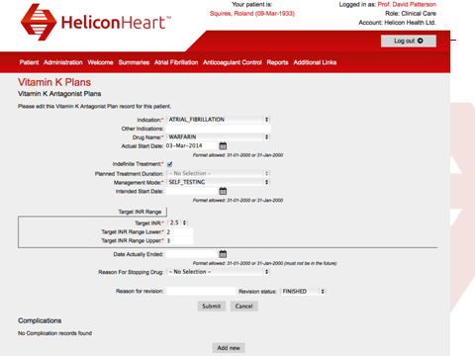

(Placeholder for ANTICOAGULANT PLAN FOR WARFARIN )

Because there are new classes of oral anticoagulants available, a choice must be made between the Vitamin K antagonists (VKA) - these include warfarin, acenocoumarol and phenindione - and the NOACs (New Oral Anticoagulant Drugs) - these are also called Oral Direct Inhibitors (ODIs). This choice will have been made prior to using the CDSS.

Moreover if there is an existing open plan for one of the NOACs, the user will not be allowed to open the VKA plan screen. This is to ensure that the two drugs will never be prescribed together. This will occur in the reverse direction as well; if a patient already has a open VKA plan the user will be denied access to the NOAC screens, including the NOAC plan screen, until it has been closed.

DEMONSTRATE YOUR SKILL

On Helicon Heart please do the following:
i) Enter a patients demographic details and their NHS number
ii) Enter a GP for the patient
iii) Create a VKA plan for someone with AF (atrial fibrillation) who will be on warfarin indefinitely

6.2 Using the CDSS in HeliconHeart – initiating warfarin therapy

Within HeliconHeart’s CDSS there are several types of dosing algorithm. It is imperative that the correct one is used for the situation in hand. For treatment initiation, algorithms based on the weekly controller (for outpatient initiation) or the daily controller (for inpatient initiations) should be used.

6.3 Using the CDSS in HeliconHeart - the maintenance dose algorithm

For maintenance therapy, the maintenance algorithm should be used; this algorithm cannot be used for initiating warfarin. The maintenance algorithm used in HeliconHeart was developed by Vadher, Patterson and Leaning and its use by a nurse practitioner has been shown to enable the nurse to function at an “expert level”. This maintenance algorithm is incorporated into HeliconHeart

PLACEHOLDER for HeliconHeart clinic contact screen

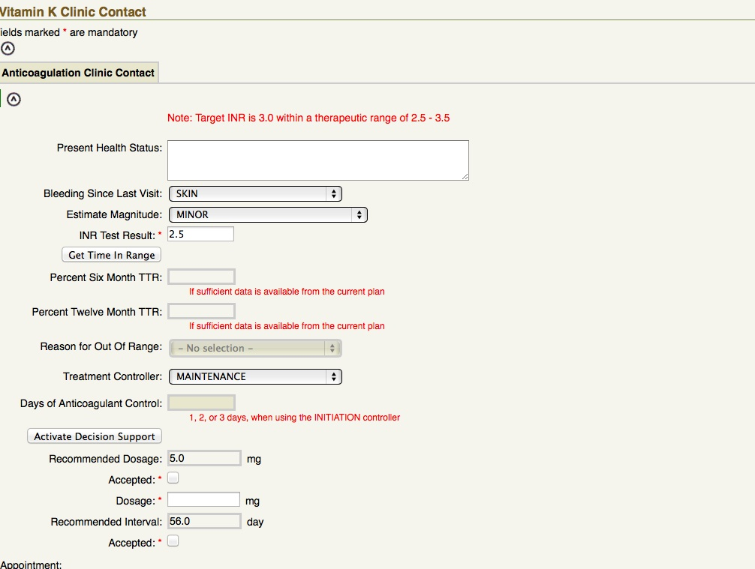

When an INR value falls outside accepted values, the clinician firstly needs to determine the cause of this deviation. If an INR is out of range because of a temporary reason including missed doses or the introduction of a short-term medicine such as an antibiotic, then practitioners should select ‘temporary reason’. If there are long-term/permanent changes including long-term health changes, e.g. heart failure or permanent medication changes such as introduction of simvastatin in hypercholesterolaemia, then the practitioners should select ‘permanent reason’. After establishing the cause and whether it is a temporary or permanent reason, a dose adjustment together with a suggested interval will be recommended. The paper-based schema follows the same pattern.

If you would like to learn more about how this algorithm was validated, please take a look at this paper (note subscription required to view full text):

Vadher BD, Patterson DLH, Leaning MS. Comparison of oral anticoagulant control by a nurse-practitioner using a decision-aid system with that by clinicians. J. Lab. Haem 1997 19: 203-207 http://www.ncbi.nlm.nih.gov/pubmed/9352146#

DEMONSTRATE YOUR SKILL

You will find two ‘patients’ set up for you on HeliconHeart. For each patient, please complete a clinic visit and generate dosing and interval advice

Patient 1 – INR target 3.0 Range 2-3
Warfarin dose 6 mg daily
Todays INR 1.5

Has been eating a lot of salads, avocado pears and leafy green vegetables

Patient 2 - INR target 3.6 Range 3 – 4
warfarin dose 8mg
Todays INR 6.7

Was started on amiodarone 2 weeks ago – will be on it for next few years

7. Paper-based decision support

Paper-based decision support can be useful where access to CDSS is not possible. The schema in use at Whittington Health can be found here. (link file ->11_hcp_decision support_extra content_ver1)

DEMONSTRATE YOUR SKILL

Take some time to familiarise yourself with the paper-based schema. Then, when you are ready, test yourself (with or without a colleague) in each of the ranges and both high and low levels to gain confidence in determining the right dose and interval for the examples you choose. You can start this activity by using the examples below.

Example 1
A patient who is generally stable on an oral anticoagulant dose of 6 mg. He has a target
INR of 2.5; today’s measured INR is 1.8 and there is a reason for his reduced INR – he missed a dose.

CORRECT ANSWER (click to reveal): He should receive 9 mg as a stat loading dose today, then return to his usual dose of 6mg daily from tomorrow.

Example 2
A patient who is generally stable on an oral anticoagulant dose of 4 mg. She has a
target INR of 2.5; today’s measured INR is 4.2 and she has just finished a course of
antibiotics.

CORRECT ANSWER (click to reveal): She should miss one dose of warfarin today, then return to her usual dose of 4mg daily from tomorrow. (If a change in dose is required, adjustments should usually be by ± 10%.)

The patient then tells you that they will be initiating another interacting antibiotic; then it may be appropriate to adjust the dose downwards by 10% in anticipation of the expected elevation, and only returning to the original warfarin dose on termination of the antibiotic and an INR check.

Example 3
Patient has an INR target of 3.5, and measured INR of 2.5. His current dose is 6mg daily. No obvious cause can be established.

CORRECT ANSWER (click to reveal): Increase his dose to 7mg daily (a little over 10% increase.) Consider a stat loading dose of 9mg for one day only.

Example 4
Patient has an INR target of 2.5, and measured INR of 4.0. His current dose is 5mg daily. The reason for the high INR is the introduction of simvastatin, a drug known to decrease warfarin metabolism, resulting in an elevated INR.

CORRECT ANSWER (click to reveal): You reduce his dose to 4.5 mg daily. This is most easily taken as 4mg / 5mg on alternate days – in other words 4 mg will be taken on even dates and 5mg on odd dates – this means that the patient is using daily dosing.
It also means that the patient avoids the need to split tablets (the use of 0.5mg tablets is not recommended as they are white in colour and could be confused with other medication).

Example 5
Patient has an INR target of 3.5, and measured INR of 4.7. His current dose is 1mg
daily (or 7mg weekly). He has been initiated on amiodarone for AF. Amiodarone is an enzyme inhibitor, thus inhibiting warfarin metabolism, and resulting in elevated INRs.

CORRECT ANSWER (click to reveal): You initially advise the patient to omit one dose. You then reduce his weekly dose to 6 mg weekly (equivalent to 0.9mg daily), to be taken as 1mg daily, except for Sunday when he does not take any warfarin.

DEMONSTRATE YOUR UNDERSTANDING

Now try the answering the questions at the start of this topic again. Did you get a higher score?

